Crime Arrest Prediction Using Stacking Ensemble Learning

DEEPA P, JAYASANJAY T, JAYA SABARI R

*Department of Computer Science and Engineering Panimalar Engineering college*

Chennai, India

[deepa@hotmail.com,](mailto:deepa@hotmail.com) jayasanjaycse@gmail.com, jayasabariimmi@gmail.com

*Abstract***-Accurate evaluation of events associated with an arrest has important ramifications for public safety and the allocation of police resources. This paper outlines a stacked ensemble machine learning method to use crime data for the prediction of policing events using Random Forest and XGBoost classifiers with a Multi Layer Perceptron meta-model. The research includes a considerable amount of preprocessing of the data (i.e., imputation, one- hot encoding, and scaling) in order to address significant missing data and heterogeneous features of a structured data set. The ensemble classifier provided the best performance, based on classification metrics (i.e., accuracy, precision, recall, F1 score, and ROC-AUC), on a real-world balanced crime data set. The model may be serialized after training for implementation within different policing environments. The study concludes with evidence that stacking classifiers does improve prediction accuracy and generalizability in a predictive urban arrest data set, and also suggests that the practice could be applied towards policing automation, pre- emption policing or Big Data analytical practices within crime**

**Keywords— crime prediction, arrest prediction, ensemble learning, stacking classifier, Random Forest, XGBoost, neural networks, machine learning**

# INTRODUCTION

Anticipating arrests of crime is significant in promoting public safety and enhancing law enforcement decision-making. Historically, forecasting crime has relied on past statistics and rules that are reliable at a singular point in time. For the most part, these conventional approaches to

crime forecasting struggle with the complexity and dynamic nature of urban crime data. The nature of crime data is heterogenous/mixed and usually contains missing values and both numerical and categorical features, creating challenges for modeling.

Although machine learning models are capable of high accuracy rates in controlled experimental conditions using curated datasets, real-world crime data tends to reveal that machine learning models do not perform as well due to issues such as data imbalance, feature mismatch, and changing nature of crime. In addition to these issues, accurately predicting arrests entails accounting for the spatial and temporal nature of crime and incorporating multiple socio-demographics related variables.

To face these challenges, this research proposes a stacking ensemble machine learning pipeline that combines Random Forest and XGBoost base classifiers with a neural network as the final learner. The pipeline also includes robust preprocessing (imputation, one-hot encoding, and feature scaling) to ensure reliability and generalizability of the model. The goal of this study is to achieve state-of- the-art predictive performance and allow for practical implementation by serializing the model.

## Unique and Integer Stacked Ensemble Model:

A stacking ensemble model, involves two base classifiers - a random forest and XGBoost - and a neural network defines the meta-learner base classifier. This is the origin of additional learning from appropriately stacking the two classifiers' outputs, and the performance gets even better with the predictive classifications of arrests for the crimes model, that is bi-variate.

Intent-based Threat Classification continues the crime analytic component of intent classification, which is intended to classify the predictive arrests

based on not just a binary rate for the arrestee, but also the intent or context. Together, this should elicit a better overall threat level assessment in that the predictive outputs are now linked with actionable intelligence or crime type for consideration in recommendations for intervention.

## Real world evaluation

The model as proposed will be trained and evaluated on real, balanced, crime, data from the real world from different cities. The value of real-world evaluations of the model demonstrates academic rigor in that the predictions are actionable, they can be generalized to the circumstance, and they can be in reality actionable to reach out to the law enforcement personnel, dramatically changing decreased referrals and costing virtually nothing versus a theoretical or synthetic model to benchmark against.

# LITERATURE SURVEY

Yadav et al.[1] created a modified autoregressive integrated moving average (ARIMA) model for spatio-temporal prediction of crime and provided more credible forecasts than classical techniques. Their study provided enhanced reliability and belief epidemiology to law enforcement, especially for policing complicated crimes with continuous time transitions and within an evolving environment.

Dong et al [2] studied the effect of spatial correlation in communities that varied in crime densities, and they found that models that combined local spatial characteristics improved the predictive performance of the model and were more effective for resource allocation. This study showed the importance of variables that were context-sensitive to the modeling of urban crime data and the funding of security strategies.

Sudhakar et al [3] suggested predicting crime in a hybrid GRU and ARIMAX framework, whereby the GRU best captured nonlinearities and the ARIMAX performed better because of its time series structure. The hybrid model displayed better performance than both models alone suggesting that considering the complexity of the temporal aspect yielded a more precise forecast for complicated events such as this.

Yao et al [4] employed a random forest for spatial crime hot-spot prediction and indicated that geospatial features improved prediction accuracy for incidences occurring in high-risk zones. The researchers also determined that the appropriateness

and transparency of random forest supports good actionable insights, allowing effective strategic operational planning based on predictions that can be interpreted..

K. T. M et al [5] examined machine learning models to predict crime type and occurrence, showing that while ensemble approaches produced the highest accuracy and consistency, appropriate feature selection and tuning are just as critical for operational viable crime prevention and strategy.

Yadav et al [6] utilized time series autoregression techniques which provided interpretable predictions and robust trend modeling that were useful for comprehending and predicting crime trends in a real-world police resource scheduling context..

Almaw and Kadam [7] examined an ensemble learning approach for the analysis of crime data and found noteworthy improvements in predictive accuracy through combining or blending multiple models. Their findings demonstrate ensembles as effective strategies for adaptive crime forecasting within practice-oriented, or operational, law enforcement contexts.

Sharma et al [8] was the first to apply fuzzy logic to geo-spatial crime categorization and safe route prediction, advancing the research agenda on context-aware navigation systems based on fuzzy logic and risk assessments for travel advisories and public safety applications..

According to Jiang et al [9] deep learning LSTM networks were applied to crime data emphasizing space and time, and LSTM's ability to model sequences improved forecasting in the short and long term, bettering the quality of predictions for sudden spikes in crime and routine cycles of crime.

Thomas and Raja [10] implemented mapping and predictive analytics on Maryland crime statistics, spotting emerging crime trends to inform strategic resource allocation and proactive policing for local law enforcement agencies.

Chakraborty et al [11] investigated empirical crime rate prediction methods and noted technological challenges, the need for improved data quality, and future research opportunities to maximize the utility of models in real-world policing contexts.

Acampora and Vitiello [12] utilized LIME, a model-

agnostic technique, to locally explain crime prediction models while also increasing interpretability. Their method supports the future handing of transparent, trustworthy AI to facilitate ethical and responsible policies in the sensitive area of,policing.

Shamsuddin et al [14] investigated crime forecasting methods, synthesizing what is known as retrospective approaches in addition to contemporary practices, and highlighting the advancements made while recognizing the challenges existing for practitioners looking to enhance the value predictive policing models.

1. PROPOSED METHODOLOGY
   1. ***System Architecture***

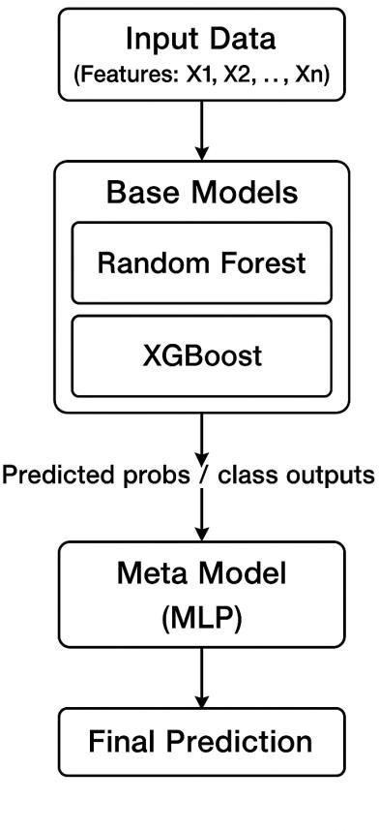

***Fig.1 Proposed Architecture B.Methology***

* + 1. ***Collection and Processing of the Data***

The initial dataframe is instantiated and removed from a number of noise columns (ID, Case Number, Date, Updated On, Location). The target variable is "Arrest", which is casted to binary type:

data= pd.read_csv("/content/balanced_crime_data.csv")

cols_to_remove = ["ID", "Case Number", "Date", "Updated On", "Location"]

data = data.drop([c for c in cols_to_remove if c in data.columns], axis=1)

X = data.drop("Arrest", axis=1) y = data["Arrest"].astype(int)

X_train, X_test, y_train, y_test = train_test_split( X, y, test_size=0.2, stratify=y, random_state=42 )

## Extraction of features

Features can be grouped into numeric or categorical sets. Numeric features are treated with median imputation and then standardized scaled:

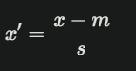

where m are sample mean and s are the sample standard deviation.

Categorical features are given univariate imputation of missing values with the mode category and then performed one-hot encoding (creating numerc vectors). Unseen categories can be incorporated gracefully with ohe as well.

num_preprocess=Pipeline(steps=[("median_impute ",SimpleImputer(strategy="median")),("normalize", StandardScaler())])

cat_preprocess=Pipeline(steps=[("mode_impute",Si mpleImputer(strategy="most_fr equent")),("onehot",OneHotEncoder(handle_unkno wn="ignore"))])

preprocessor = ColumnTransformer(transformers=[ ("numeric", num_preprocess, numeric_features), ("categorical",cat_preprocess,categorical_features)

])

## Phase 1: Base Models

The ensemble is built from two base classifiers:Random Forest Classifier (bagging

ensemble):

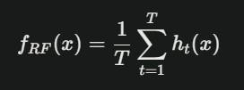

are individual decision trees, T = 100 trees.

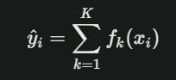XGBoost Classifier (gradient boosting):

*passthrough=True, n_jobs=-1*

*)*

## v) Training and tuning the model.

The entire pipeline of a preprocessing and stacking classifier is applied to the training data.

pipeline = Pipeline ([ ("preprocessor", preprocessor), ("stacking", stacking_clf)

where each fk is a regression tree fit to minimize the logistic loss.

ensemble_models_candidates=[("forest", RandomForestClassifier( n_estimators=120,n_jobs=-1,random_state=42, max_depth=None)),

("boosted_tree",XGBClassifier(n_estimators=180,l earning_rate=0.06, random_state=42, n_jobs=- 1,eval_metric="logloss", use_label_encoder=False

)),

]

## Phase 2: Meta Model Integration

A multi-layer perceptron (MLP) neural network serves in the role of a meta-learner. As inputs to the meta-learner, the model will take the output of the base models along with the original features (using passthrough=True) and learn the weighted combination of features while also learning nonlinear interactions:

*meta_learner=MLPClassifier( hidden_layer_sizes=(128, 64), activation="relu", solver="adam",*

*max_iter=250, random_state=42*

*)*

*stack_model=StackingClassifier( estimators=ensemble_candidates, final_estimator=meta_learner,*

])

pipeline.fit(X_train, y_train)

Model tuning entails hyperparameter searching in base and meta models, early stopping via max iteration limits, and the ability to perform processing in parallel. After this, the model could be serialized and saved for further use.

joblib.dump(pipeline,"/mnt/data/stacking_crime_m odel.pkl")

## vi) Deployment Architecture

The modular pipeline design supports:

. Local assessment via command line interface or callable Python modules.

. Simple integration into larger crime analytics platforms.

. The possibility of extending to RESTful APIs for live production systems.

This flexibility allows for rapid prototyping, verification, and eventual deployment into operational law enforcement environments.

# EXPERIMENTAL APPROACH

## Hardware and Software Environment

The experiments were conducted on a personal computer (PC) characterized by a multi-core (Intel or AMD) CPU, with 16-32 GB of RAM, and, in particular, an SSD hard drive (for the actual data science work, as this will give the fastest access). Where it was beneficial, experiments would also utilize the GPU to further enhance the training of models such as XGBoost and the neural network.

As mentioned earlier in the survey of literature, I have chosen for this project to implementation it in Python (3.8 or higher as used in all the recent code)

in Google Colab / Jupyter Notebook to make… a more dynamic, cloud-based and interactive project. For this project, the libraries used were: pandas for representing datasets, numpy scales for numerical exercise, scikit-learn load for pre-processing, classification models and evaluation metrics, xgboost for classification using gradient boosting, and joblib for saving and reloading trained pipelines (with some optional visualisation of results as well) using visualisation libraries (matplotlib, seaborn).

## Dataset Characteristics

The dataset obtained from Kaggle was balanced by the addition of duplicates to compensate for the class imbalance between arrests and non-arrests. The target variable "Arrest" is binary: 1 indicates arrest made, and 0 indicates no arrest.

Categorical variables in the dataset include descriptions of crimes: IUCR, Primary Type, Description, Location Description, Domestic, FBI Code, and Block. The dataset also contains numerical variables that refer to spatial and administrative dimensions, including Beat, District, Ward, Community Area, X Coordinate, Y Coordinate, Latitude, Longitude, and Year.

Certain attributes including ID, Case No., Date, Updated On, and Location were dropped from study due to low predictive value and privacy issues, as unique identifiers may exacerbate risk factors with officers or administrators.

In data preprocessing, missing numerical values were handled with median imputation and missing categorical values were handled with most-frequent value imputation. Categorical variables were one- hot encoded and numerical variables were standardized. After preprocessing, the dataset was cleaned, harmonized, and set up appropriately for effective modeling.

## Evaluation Procedures

The dataset was split into an 80%-20% train-test split, while maintaining class distribution using a stratified split. Furthermore, five-fold crossvalidation was performed while training of models to ensure that the models were robust and to mitigate variance in performance of models.

The models were evaluated on multiple evaluation criteria to evaluate accuracy generally, and accuracy per class:

Accuracy - proportion of instances that were predicted correctly to class.

Precision - proportion of predicted arrests that were correct.

Recall (Sensitivity) - proportion of actual arrests that were detected correctly.

F1 Score - harmonic mean of precision and recall; balance between false positives and false negatives.

ROC-AUC - AUC is the measure of discriminatory capability at for a variety of cutoffs.

Additional diagnostics including confusion matrices, precision-recall curves, and ROC curves provided visualizations of the trade-off between precision and recall. Random seed were independently fixed for reproducibility and the entire workflow from pre-processing to modeling was saved with joblib.

# RESULTS AND DISCUSSION

## Phase 1

In phase one, each of the individual base learners (Random Forest and XGBoost) Model was fitted to the data separate from one another. Although the base learners were both high-performing models, their outputs were slightly differently across metrics, suggesting that an ensemble approach was warranted to combine the two base learners.

## Phase 2

Phase 2 presented the stacking ensemble structure, in which the learning predictions were handed off to an MLPClassifier acting in the capacity of meta- learner. This structure facilitated learning by leveraging tree-based and neural patterns in an ensemble manner, producing better predictions.

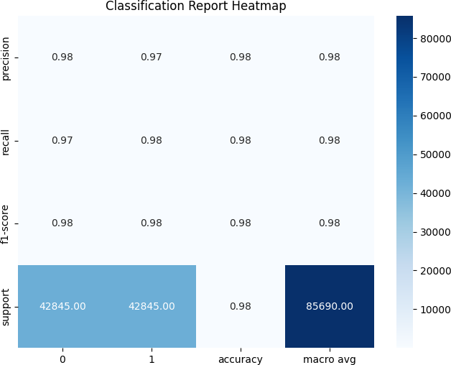

## Fig.2 Heatmap

* 1. ***Comparative Analysis***

When individual base learners were compared to the ensemble, it was found that the stacking classifier consistently outperformed single models. The ensemble delivered values of:

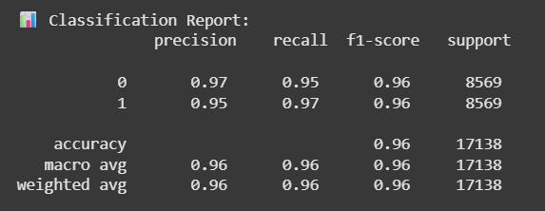

**Fig.3 Classification Report**

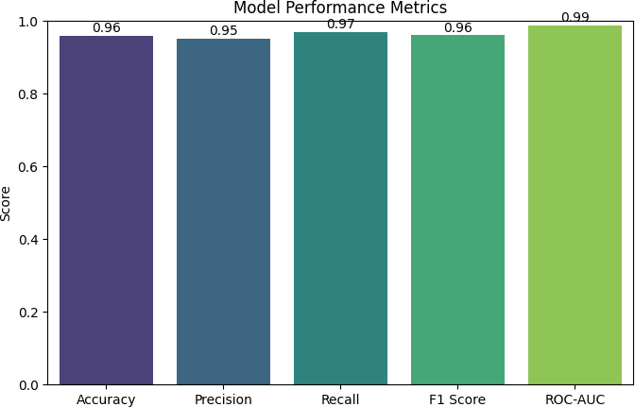

**Fig.4 Performance Metrics**

## Confusion Matrix

The finished system achieved a total accuracy of 96%, indicating a high level of trustworthiness in predicting arrest outcomes. In addition, the confusion matrix indicates that it accurately predicted most of the “Arrest” and “No Arrest” cases with a very few number of incorrect classifications.

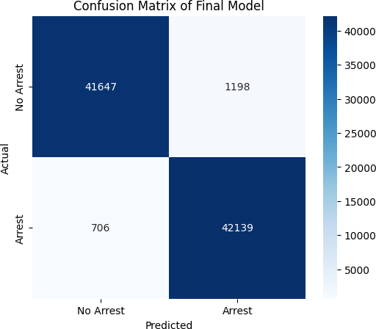

**Fig.5 Confusion Matrix**

# CONCLUSION AND FUTURE WORK

To sum up, this paper has demonstrated that it is feasible to create a new stacking ensemble framework that employs Random Forest and XGBoost as the base models, while also including a neural network as the meta-classifier, and that this framework increases the accuracy of crime arrest prediction compared to simpler models. The overall assessment of the ensemble was validated through multiple metrics and confusion matrix metrics, and its overall robustness and reliability have been confirmed for use. The framework’s modular and scalable design will allow for easy adaptability in future datasets, as urban crime records continue to develop, offering the police a practical predictive policing framework for efficient resource allocation and enhanced public safety.

Future research may focus on integrating varied additional base learners as well as meta-classifiers into the framework to further improve performance. Also, if the stacking ensemble is expanded to include real-time spatiotemporal crime data and/or socio-economic risk factors, predictability may improve even more. Additionally, if the stacking ensemble had features that provided explanations for each respective decision made, the stacking ensemble may be more trustworthy and transparent to law enforcement agencies, while crafting AI in a responsible and ethical manner when thinking about crime prediction.

# REFERENCES

1. R. Yadav and S. Kumari Sheoran, "Modified ARIMA Model for Improving Certainty in Spatio-Temporal Crime Event Prediction," *2018 3rd International Conference and Workshops on Recent Advances and Innovations in Engineering (ICRAIE)*, Jaipur, India, 2018, pp. 1-4, doi: 10.1109/ICRAIE.2018.8710398.
2. Dong, R. Ye and Y. Fan, "Impact of Spatial Correlation on Crime Prediction in Communities with Different Crime Densities," *2022 IEEE 8th International Conference on Computer and Communications (ICCC)*, Chengdu, China, 2022, pp. 2227-2233, doi: 10.1109/ICCC56324.2022.10065938.

[3]A. Sudhakar, D. C. Nandini, P. G. Bhavani and L. L. Priyanka, "Hybrid Crime Prediction Using GRU and ARIMAX Models," *2025 8th International Conference on Trends in Electronics and Informatics (ICOEI)*, Tirunelveli, India, 2025, pp. 1510-1516, doi: 10.1109/ICOEI65986.2025.11013209.

1. S. Yao *et al*., "Prediction of Crime Hotspots based on Spatial Factors of Random Forest," *2020 15th*

*International Conference on Computer Science & Education (ICCSE)*, Delft, Netherlands, 2020, pp. 811- 815, doi: 10.1109/ICCSE49874.2020.9201899.

1. K. T. M, L. T. N, M. Ithihas, N. R. Shetty, A. H. N

and S. Hebbar, "Crime Type and Occurrence Prediction Using Machine Learning," *2024 Second International Conference on Advances in Information Technology (ICAIT)*, Chikkamagaluru, Karnataka, India, 2024, pp. 1-5, doi: 10.1109/ICAIT61638.2024.10690652.

1. R. Yadav and S. Kumari Sheoran, "Crime Prediction Using Auto Regression Techniques for Time Series Data," *2018 3rd International Conference and Workshops on Recent Advances and Innovations in Engineering (ICRAIE)*, Jaipur, India, 2018, pp. 1-5, doi: 10.1109/ICRAIE.2018.8710407.
2. A. Almaw and K. Kadam, "Crime Data Analysis and Prediction Using Ensemble Learning," *2018 Second International Conference on Intelligent Computing and Control Systems (ICICCS)*, Madurai, India, 2018, pp. 1918-1923, doi: 10.1109/ICCONS.2018.8663186.
3. S. Sharma, A. Uniyal, P. Srinivasan and S. Chaudhari, "Fuzzy Based Geo-Spatial Crime Category Prediction for Crime Mapping and Safe Route Travel," *2022 IEEE Region 10 Symposium (TENSYMP)*, Mumbai, India, 2022, pp. 1-6, doi: 10.1109/TENSYMP54529.2022.9864342.
4. N. Jiang, K. Miao, Y. Chai, D. Lu and J. Wu, "Spatio- temporal prediction of crime based on Data Mining and LSTM network," *2023 IEEE 6th Information Technology,Networking,Electronic and Automation Control Conference (ITNEC)*, Chongqing, China, 2023,

pp. 672-676, doi: 10.1109/ITNEC56291.2023.10081985.

1. B. A. Thomas and S. Raja, "Crime Mapping and Predictive Analysis of Crimes in Maryland, USA," *2024 International Conference on Signal Processing, Computation, Electronics, Power and Telecommunication (IConSCEPT)*, Karaikal, India, 2024, pp. 1-6, doi: 10.1109/IConSCEPT61884.2024.10627834.
2. K. Chakraborty, D. B, M. Sharma, D. Thakral, P.K.Hemalatha and H. S. Arri, "Empirical Approaches to Crime Rate Prediction: Challenges, Insights, and Future Directions," *2024 International Conference on Augmented Reality, Intelligent Systems, and Industrial Automation (ARIIA)*, Manipal, India, 2024, pp. 1-6, doi: 10.1109/ARIIA63345.2024.11051967.
3. M. Geetha Vadav, R. N, E. S. Reddy, M. S. Vishal and G. Vishal, "The Role of Machine Learning in Crime Analysis and Prediction," *2024 International Conference on Expert Clouds and Applications (ICOECA)*, Bengaluru, India, 2024, pp. 885-890, doi: 10.1109/ICOECA62351.2024.00157.
4. A. Gangwar, D. Bisht, S. Choudhary, V. Chauhan and V. Tomar, "An Analytical Comparison of Crime Prediction using Machine Learning Techniques," *2024 International Conference on Electrical Electronics and Computing Technologies (ICEECT)*, Greater Noida, India, 2024, pp. 1-6, doi: 10.1109/ICEECT61758.2024.10739168.
5. G. Acampora and A. Vitiello, "Local Interpretable Model-agnostic Explanations for Crime Prediction," *2025 IEEE Symposium on Trustworthy, Explainable and Responsible Computational Intelligence (CITREx Companion)*, Trondheim, Norway, 2025, pp. 1-4, doi: 10.1109/CITRExCompanion65208.2025.10981498.
6. N. H. M. Shamsuddin, N. A. Ali and R. Alwee, "An overview on crime prediction methods," *2017 6th ICT International Student Project Conference (ICT- ISPC)*, Johor, Malaysia, 2017, pp. 1-5, doi: 10.1109/ICT-ISPC.2017.8075335.
7. K. B. Sundharakumar, N. Bhalaji and M. Muthu Palaniappan, "Spatio Temporal Modelling of Repeat Crimes and Hotspots Prediction Using Recurrent Deep Neural Networks," *2024 5th International Conference on Innovative Trends in Information Technology (ICITIIT)*, Kottayam, India, 2024, pp. 1-6, doi:10.1109/ICITIIT61487.2024.1058080.
8. A. Li, M. Y. Shalaginov, A. Tao and T. H. Zeng, "Investigation of Racial Bias in Property Crime Prediction by Machine Learning Models," *2023 International Conference on Machine Learning and Applications (ICMLA)*, Jacksonville, FL, USA, 2023,

pp. 2253-2256, doi: 10.1109/ICMLA58977.2023.00340.

1. M. Tamilselvi, C. N. Ravi, S. Jayasudha, P. Shahad, S. Karthikeyan and V. S. Pandi, "HDLCP: Experimental Analysis and Development of Hybrid Deep Learning Methodology for Crime Scenario Assesment and Prediction," *2024 1st International Conference on Cognitive, Green and Ubiquitous Computing (IC-CGU)*, Bhubaneswar, India, 2024, pp. 1-6, doi: 10.1109/IC-CGU58078.2024.10530836.